Power BI Assignment 1 – Data Transformation & Data Modeling
Fathima Sabeeha T

Import Data:
In power bi get data tab select text/csv then select each file and open then load file .click transform tab so it gp to power
query editor

Data Transformation:
● Restrict the "List of Orders" table to only the first 500 rows.
Remove null value
Select list of orders table then select orders date then go remove rows click remove rows from bottom and type 60 in number of coloumn then ok

● Ensure the “Order Date” column in the “List of Orders” table is set to data type 'Date'.
There is icon in left side of headers in column click the icon and choose date

● Change the data type of “Amount” and “Target” columns to ‘Fixed Decimal Number’.
Left icon in head and choose fixed decimal number

● Format the "CustomerName" column into proper case, ensuring consistent
capitalization for each word.
Select customer name then transform tab formate capitalize each word .select filters in right side of headers and sort in ascending order .

● Merge the "State" and "City" columns to create a new column named "Location" in
the format ‘City, State’.
First select the city table and select state then in add coloumn tab then merged coloumn and type new coloumn “Location” and select comma in seprate

● Create a new custom column named "Profit Margin" as the percentage of "Profit"
divided by "Amount
Add coloum tab custom coloumn in new coloumn name “Profit Margin”in custom coloum profit /margin then ok

● Add a new conditional column named "Profit Status" based on the values in the
"Profit" column. The conditions are as follows: if the profit is less than 0, the label
should be "Loss"; if the profit equals 0, the label should be "Break-Even"; and if the
profit is greater than 0, the label should be "Profit".
Add coloum tab conditional coloumn new coloumn name profit status then give the details

Merging Data (Joins):
● Merge the "List of Orders" and "Order Details" tables into a new single table named
"Orders Data" based on the "Order ID" relationship.
In home tab merge queries and select merge queris as new then select order details and list of orders click order id in both table then ok and rename the data to orders data

Handling Missing Data & Duplicate Data:
● Identify missing values in the data and determine a strategy to address them.
● Check for duplicate rows and define a strategy to handle duplicates.
before
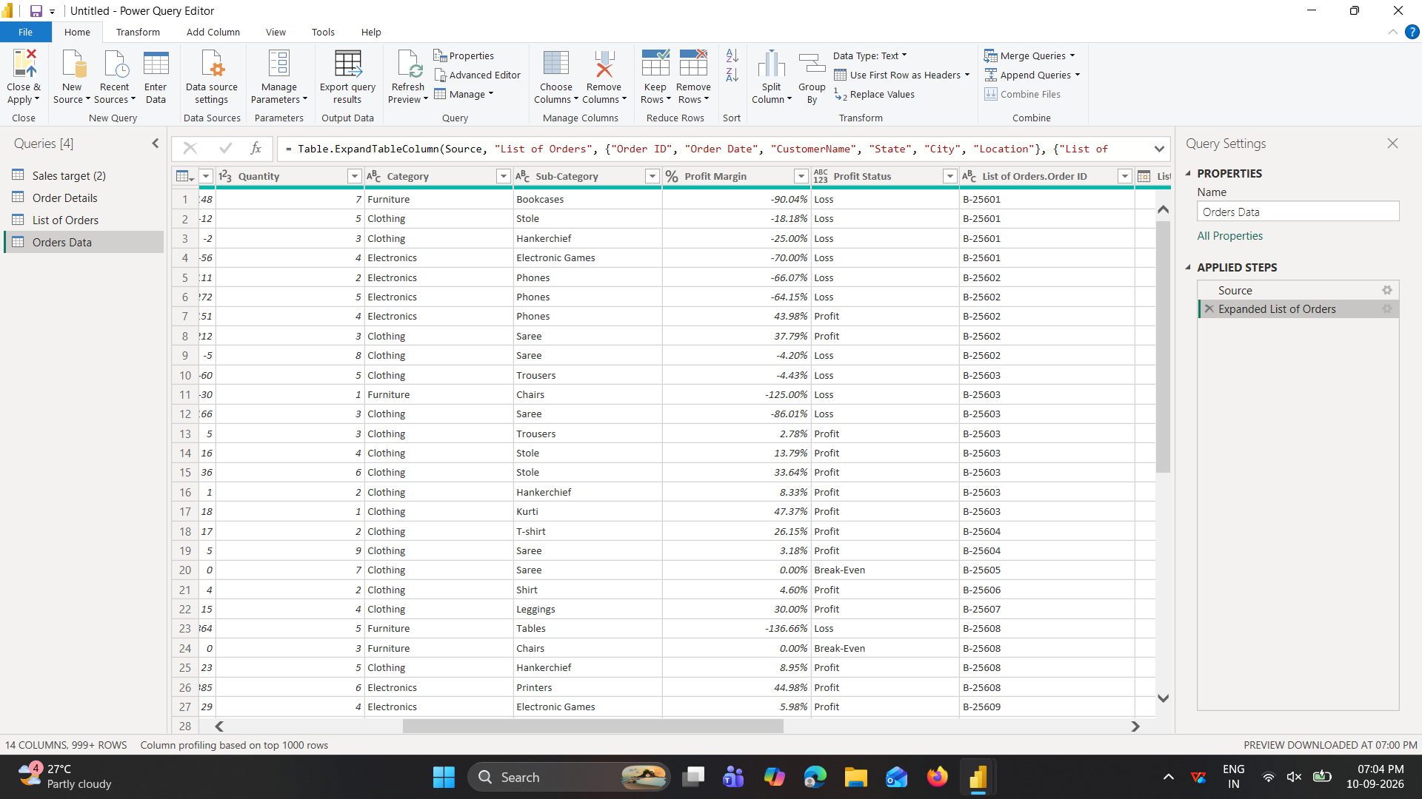
In orders data t5able there is two order id coloum so select order id and right click remove .
after
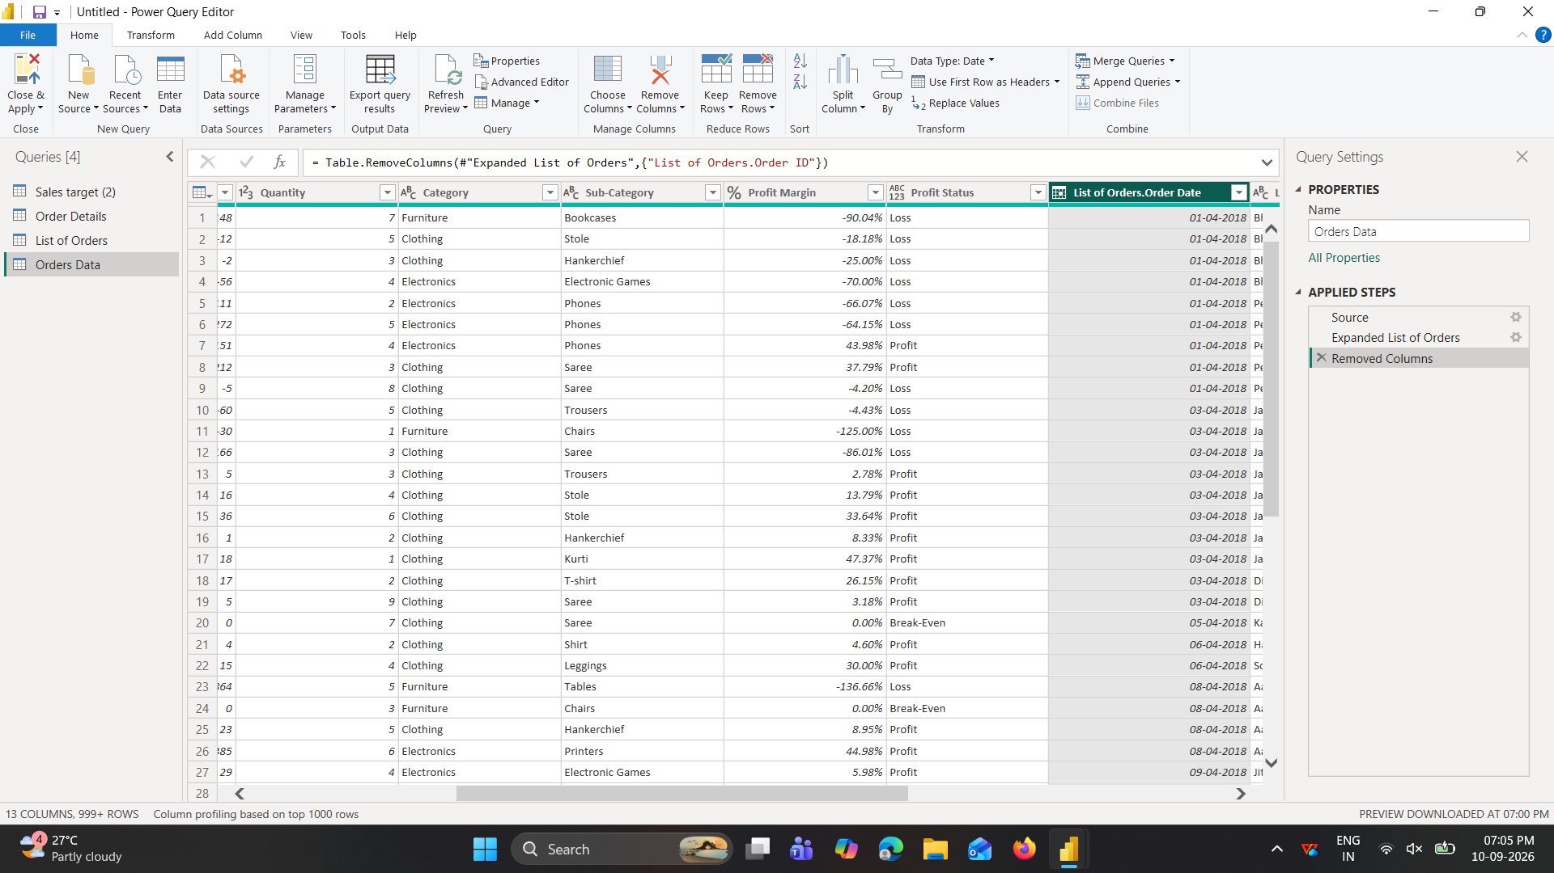

No missing value ,
Sorting and Filtering Data:
● In the ‘Orders Data’ table, utilize sorting and filtering techniques on columns like
Order Date, State or Category to analyze data based on specific criteria:
◆ Sort the orders by Order Date in descending order to analyze recent trends.
Right side of headers there is filter icon click on it and sort in descending order.
◆ Filter the orders to focus only on a specific state (e.g., Tamil Nadu) for
regional analysis.
In filter untick select all and tick in tamilnadu and press ok .
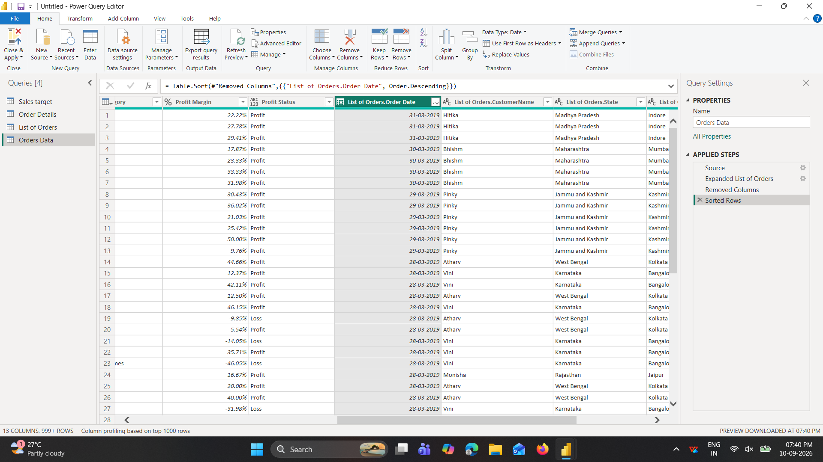

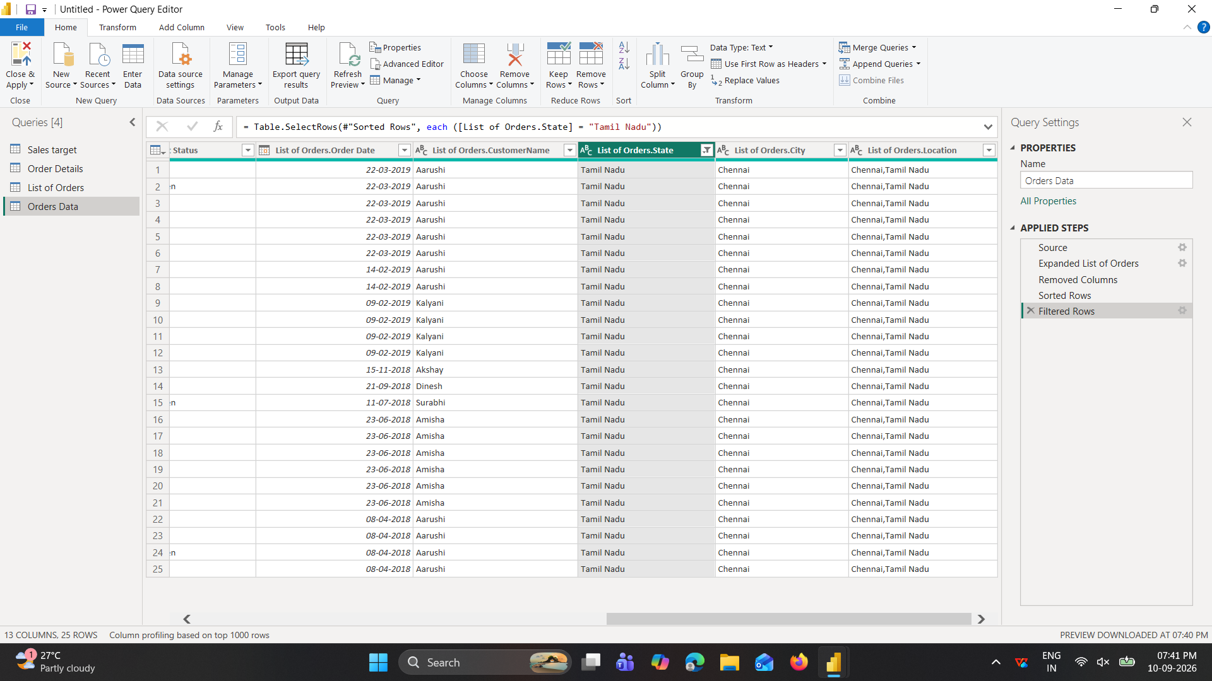

Grouping and Aggregating Data:
● Duplicate the “Order Details” table and calculate the count of each Order ID, average
profit by Category or total amount by Sub-Category.
Click data “order details” and right click select duplicate ,then click duplicate data then select order id then choose group by in hometab or transform tab then add details.in new coloumn column name “count of order id”operation=count rows, then ok.
Again select category coloumn click group bu then new coloumn “average profit” ,operation average ,column profit,
● Duplicate the “Sales Target” table and aggregate the total target amount by Month of
Order Date.
Click data “salestarget” and right click select duplicate ,then click duplicate data select target coloum then choose group by in hometab or transform tab then add details.new coloumn “total target”o,operation=sum,column order date
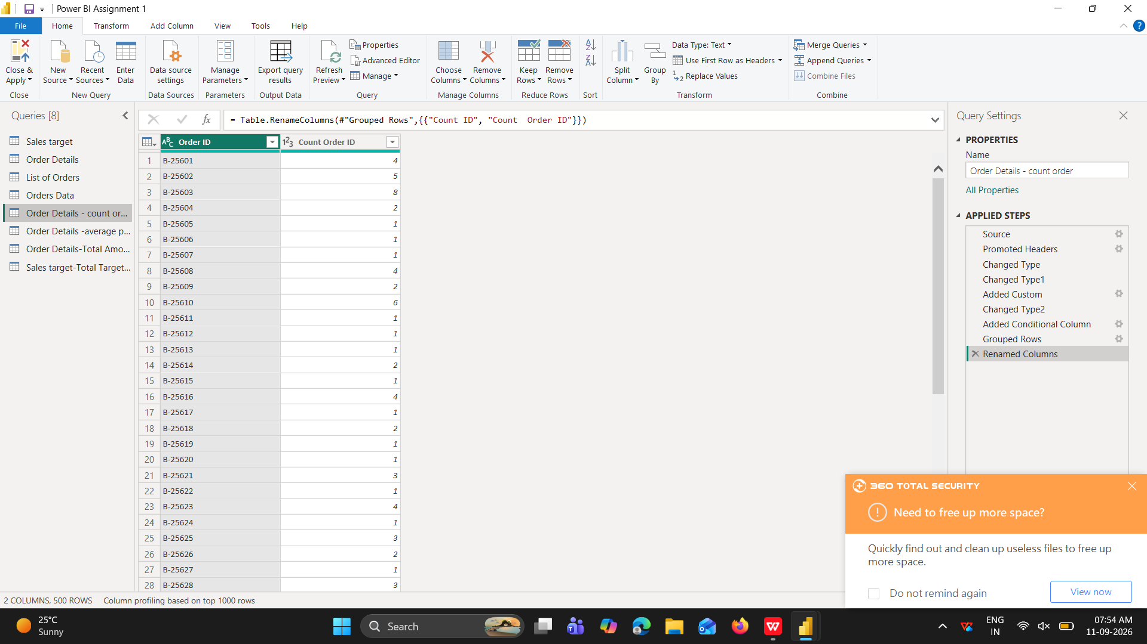

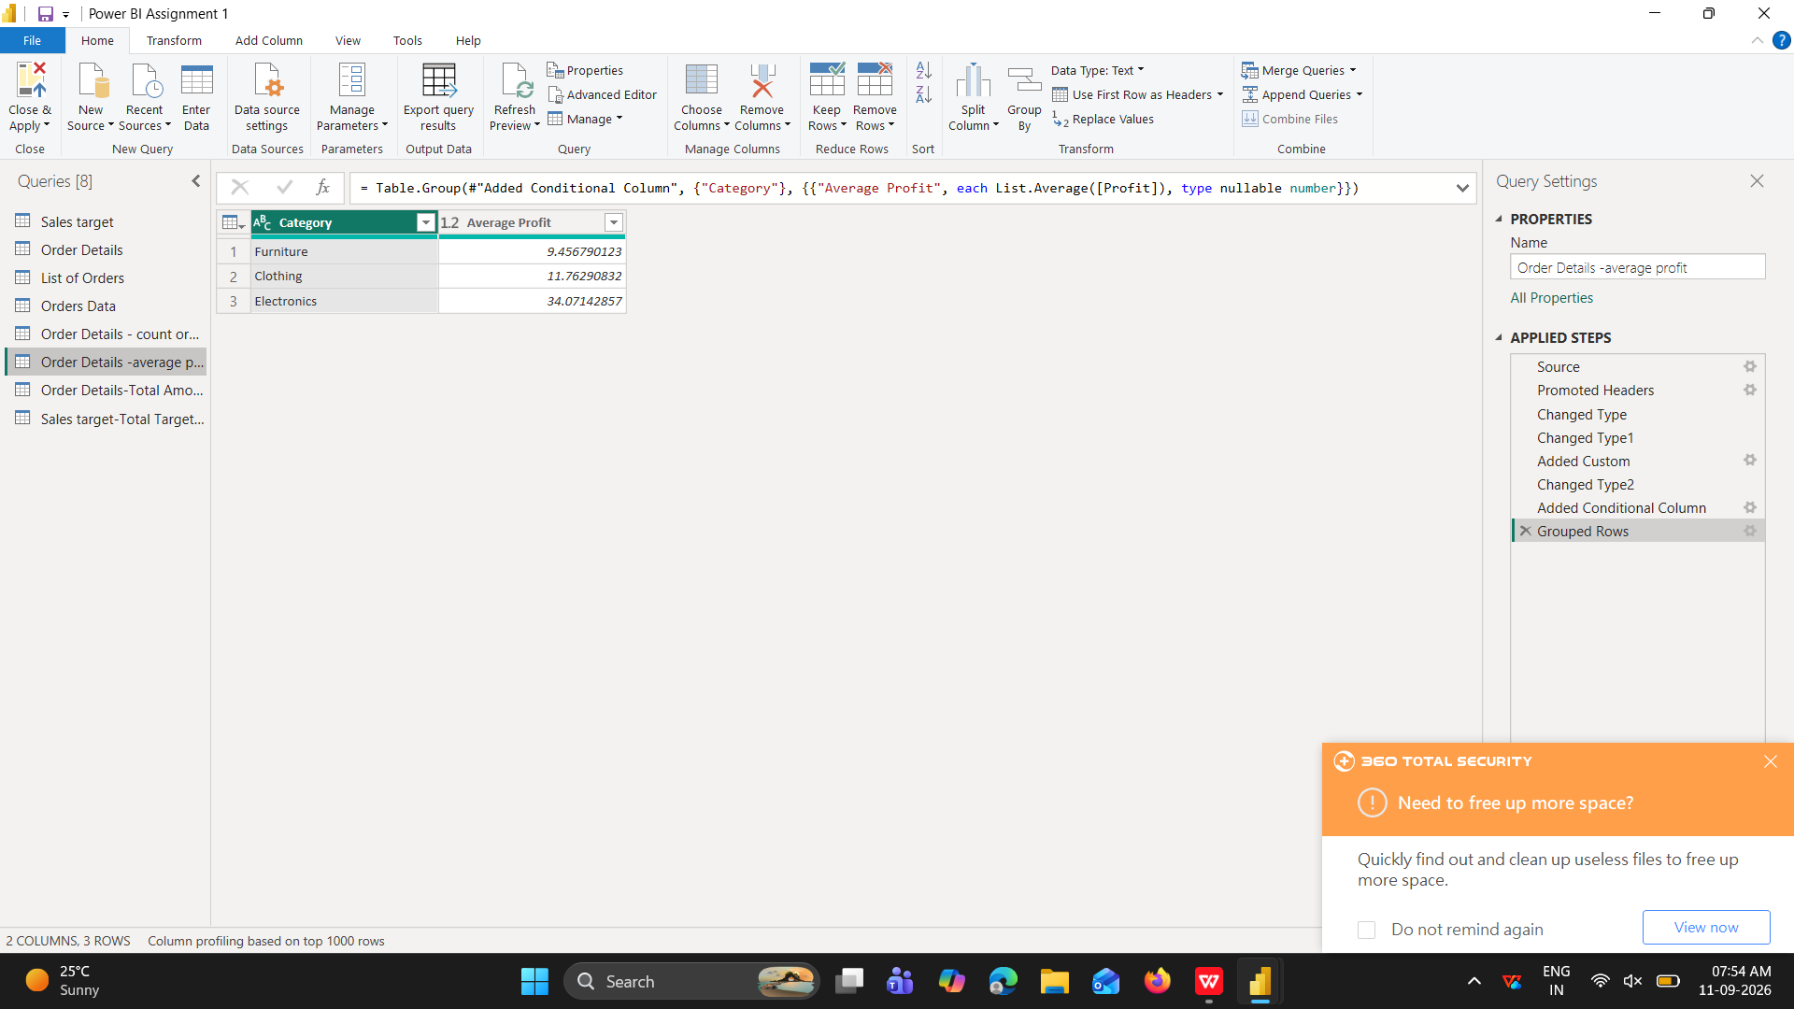

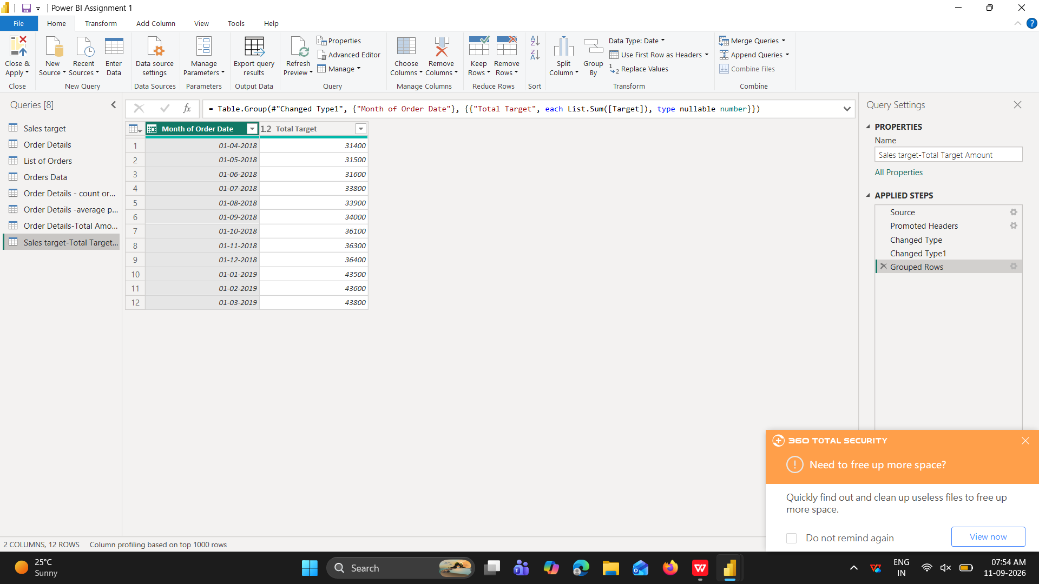
Data Modeling:
● Establish a relationship between the “List of Orders” and “Order Details” tables using
the ‘Order ID’ column.
● Build a relationship between the “Order Details” and “Sales Target” tables based on
the ‘Category’ column. Click "Manage relationships" and ensure this relationship is
active.
In power BI delete auto detect relationship
Filetab-option-data liad-untick autodetect .then mange relationship delete all relationship.then click new relathinship select list of orders table in from the table and order details in to the table and select order id in both table ,so we can see cardinality is one to many(1,*)and cross filter dirction is single.
Again same way to order detais and sales target table and there cardinality is many to many(*,*) and cross filter direction is both ok .
